***ANUDIP FOUNDATION***

A Project Report on

**“FASHION RECOMMENDATION SYSTEM”**

By

Batch: ANP-C7344

Student ID: AF0376349

Name: Pranali Sandupatla

**Under the Guidance of**

Mrs. Rajshri Chandrabhan Thete

FASHION RECOMMENDATION SYSTEM

A Fashion Recommendation System (FRS) utilize algorithms to analyze user preferences, style trends, and contextual data, delivering personalized clothing and accessory suggestions. They streamline the process of discovering new fashion items, helping users explore and discover styles that align with their tastes and preferences.

Top of Form

**Entities:**

* Admin
* User
* Fashion Item
* Occasion
* Weather
* Feedback
* Recommendation

**VARIOUS ENTITIES:**

1. **User**

* userID(Primary Key)
* userName
* email
* age
* gender
* bodyType
* preferredStyles
* favoriteColors

1. **Admin**

* adminID(Primary Key)
* email
* phoneNo
* permissions

1. **Fashion Item**

* itemID(Primary key)
* occasionID(foreign key)
* itemName
* itemType
* material
* brand
* color
* size
* season

1. **Occasion**

* occasionID(Primary Key)
* description

1. **Weather**

* weatherID(Primary key)
* temperature
* weatherType
* windspeed

1. **Feedback**

* feedbackID(Primary key)
* recommendationID
* rating
* comment

1. **Recommendation**

* recommendationID(Primary key)
* fashionItem(Foreign key)
* fashionName(Foreign key)
* weatherID(Foreign key)
* occasion(Foreign key)
* brand(Foreign key)
* color(Foreign key)

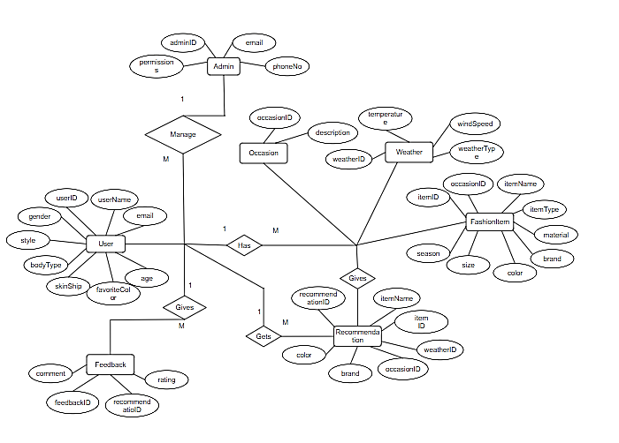**ENTITY RELATIONSHIP DIAGRAM – FASHION RECOMMENDATION SYSTEM**

**CLASS DIAGRAM FOR PATIENT MANAGEMENT:**

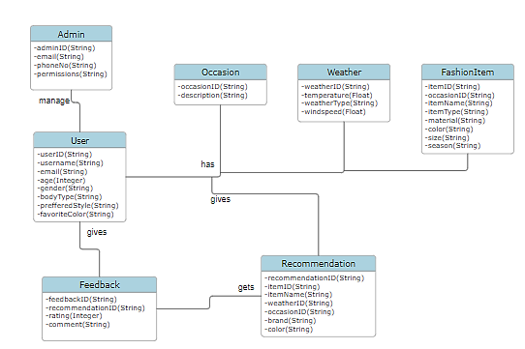

**CONCLUSION:**

In conclusion, a Fashion recommendation systems deliver personalized clothing and accessory suggestions by analyzing user preferences, style trends, and contextual data. These systems streamline the process of discovering new fashion items, helping users explore and discover styles that align with their tastes and preferences. Through advanced algorithms and data analysis techniques, fashion recommendation systems provide tailored recommendations, empowering users to make informed and confident fashion choices.

.